APA Referencing List

**[1]**

Moore, A., Schirmer, J., Magnusson, A., Keller, K., Hinten, G., & Woodhams, J. (2023, July). *Social and Economic Survey of Recreational Fishers 2018-2021*

[Review of *Social and Economic Survey of Recreational Fishers 2018-2021*]. Frdc.com.au; Fisheries Research and Development Corporation.

<https://www.frdc.com.au/sites/default/files/2023-07/victoria_rec_fishing_survey_-_web.pdf>

Pg.

4, “As of 2019-20, recreational fishing contributed just over $11 billion to the Australian economy, and over 100,000 jobs nationally.”

5, “a total of 3.81 million fishing events. Victorian fishers are more likely to go fishing in freshwater areas than people in other parts of Australia”, “findings highlight that Victoria’s young and urban residents are less likely to go fishing than their counterparts in other parts of Australia.”

(Graph(s) on pg.5)

6, “Victorian’s spend an estimated 3.8 million days fishing each year”

(Graph on pg.6)

10, (Graph and annotation on pg.10)

11, (Graph and annotation on pg.10)

**[2]**

*Fish Stock Assessments*. (2025). VFA. <https://vfa.vic.gov.au/science-in-fisheries/featured/fish-stock-assessments>

(Snapper) Pg.

2, (Graph and figure on pg.2)

3, “most of the commercial harvests are from Port Phillip Bay and have dropped considerably from ~150 t in 2010−11” “Standardised CPUE of adult snapper taken by the commercial long-line fishery and recreational anglers… in Port Phillip Bay have decreased since their peaks a decade ago”

4, (Graph and figure on pg.4)

5, (Graph(s) and figure(s) on pg.5)

(Murray cod) Pg.

1, (Graph and figure on pg.1)

“...commercial harvest of Murray cod in Victoria ceased in 2001. There is no recent information on recreational harvest or effort at state level.” “...Since about 2014–2015 CPUE appears to have increased relative to the reference period in most indicator rivers...“

(Longfin Eel) Pg.

2, “Despite strong environmental drivers that can severely reduce productivity, the Victorian Longfin Eel fishery is well-managed… openings to the sea are closed to commercial fishing.”

**[3]**

*Check air and water quality*. (2025, May 29). Vic.gov.au. <https://www.epa.vic.gov.au/check-air-and-water-quality>

(Not any “pages”, just listing here as it provides me with a roughly accurate data entry for each location, in case I have to reference it anywhere)

**[4]**

Victorian Biodiversity Atlas. (n.d.). Vba.biodiversity.vic.gov.au. <https://vba.biodiversity.vic.gov.au/vba/index.jsp>

(Same here)

**[5]**

Yao, H., Zhuang, W., Qian, Y., Xia, B., Yang, Y., & Qian, X. (2016). Estimating and Predicting Metal Concentration Using Online Turbidity Values and Water Quality Models in Two Rivers of the Taihu Basin, Eastern China. PLOS ONE, 11(3), e0152491.

<https://doi.org/10.1371/journal.pone.0152491>

(doesn't have page structure)

(Fig.3)

“The concentrations of the five metals fit well with the turbidity values… All presented good linear relationship, leading to the conclusion that the occurrence of the five metals are directly related to suspended solids” “Turbidity is strongly influenced by the properties of transported sediment, such as shape, size, and mineral composition”

**[6]**

Fondriest Environmental, Inc. (2014, June 13). Turbidity, Total Suspended Solids & Water Clarity - Environmental Measurement Systems. Environmental Measurement Systems. <https://www.fondriest.com/environmental-measurements/parameters/water-quality/turbidity-total-suspended-solids-water-clarity/>

(doesn't have page structure)

“Pollutants such as dissolved metals and pathogens can attach to suspended particles and enter the water” “When the suspended solids concentration is due to organic materials, particularly sewage effluent and decaying organic matter,... These organic suspended solids are also more likely to decrease dissolved oxygen levels as they are decomposed”

Fig.1 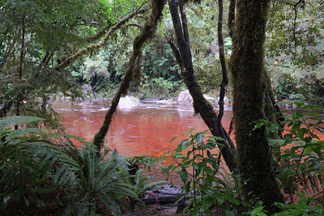

Tannin vegetation giving the water it’s murky red colour.

Fig.3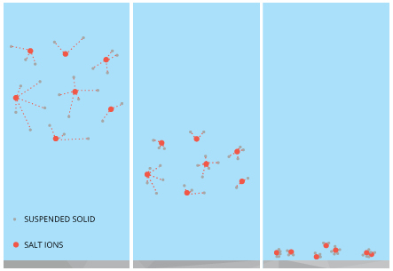

Salt ions can cause suspended particle to aggregate and settle at the bottom of a body of water.

**[7]**

Shaalan, W. M. (2024). Hazardous effects of heavy metal pollution on Nile tilapia in the aquatic ecosystem of the Eastern Delta in Egypt. BMC Veterinary Research, 20(1).

<https://doi.org/10.1186/s12917-024-04367-3>

(doesn't have page structure)

(Fig.1)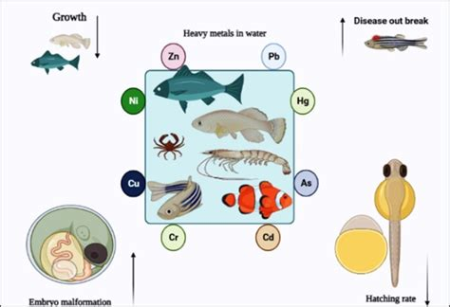

(Fig.2)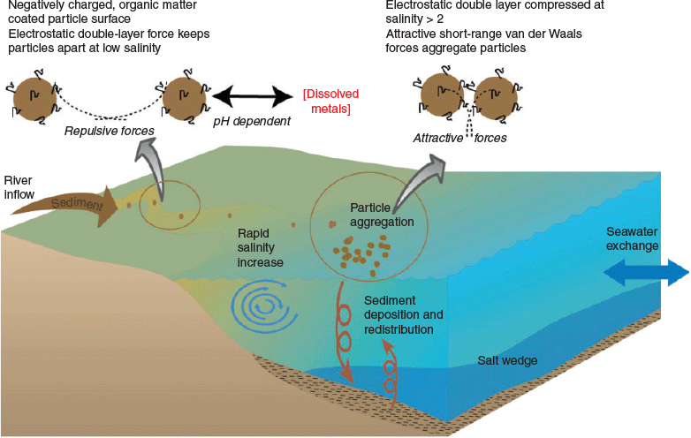

“Tilapia from the Damietta branch exhibited significant tissue damage in the body…, indicating potential health risks associated with heavy metal exposure.” “There were notable changes in the expression levels of genes related to muscle growth (MyoD, IGF-1) and immune response (TNFa, IL6) in fish” “Fish and water samples were collected from two sites: the Damietta branch of the Nile River and El-Rayah El-Tawfeeky canal in Benha City, Egypt.”

**[8]**

Jamil Emon, F., Rohani, M. F., Sumaiya, N., Tuj Jannat, M. F., Akter, Y., Shahjahan, M., Abdul Kari, Z., Tahiluddin, A. B., & Goh, K. W. (2023). Bioaccumulation and Bioremediation of Heavy Metals in Fishes—A Review. Toxics, 11(6), 510.

<https://doi.org/10.3390/toxics11060510>

(doesn't have page structure)

“Metals are particle-bound pollutants in surface water with suspended solids associated with 60–97% of total metals in surface water” “Transported suspended solids absorb metals; therefore, turbidity could be used to detect the occurrence of these pollutants.”